Choose PRINT or SAVE AS.. under your browser's FILE menu if you wish to read this article later.

Please hit the BACK button on your browser to return to website.
_______________________________________________________
Published in Management Consultancy - a Handbook for Best Practice
Edited by Philip Sadler. 1998
_______________________________________________________

CHAPTER 19: LARGE CORPORATES
By Mike Jeans & Tony Page
_______________________________________________________

When you are consulting with large corporates you may find yourself challenged in altogether different ways than with small and medium sized enterprises or public sector organisations.

Typically a large corporate produces many product lines, through many organisational units which may also be geographically dispersed across many locations, and increasingly, crossing national boundaries. Arguably this results in a similar scale of organisational complexity and inertia to that found within the public sector, but in large private sector organisations great complexity is combined with a quite different profile of values, risks and opportunities.

Take an example to underline the point. SmithKline Beecham, a global healthcare company has headquarters in London and Philadelphia, around 50,000 staff spread across laboratories, factories and offices in over 100 countries throughout the world, developing producing and selling a huge portfolio of products, some ‘ethical’ delivered through doctors’ prescription and others available over the counter through High Street retail pharmacists. The organisation was formed from a merger in 1989 of two very different organisations: the US-owned SmithKline Beckman and a UK owned conglomerate called the Beecham Group. In 1994, the complexity of culture, product portfolio and organisation was compounded by the acquisition of a third company: Sterling Health.

It is a gross oversimplification to say that “making profit” is the only value in a large corporate. You are dealing with a large employee population with a wide range of national cultures, religions, climates, lifestyles, backgrounds, and career aspirations. These differences manifest in the workplace in all sorts of ways, at times inhibiting and at other times enabling corporate performance. The large corporate usually needs to develop its own distinctive culture and values in order to engage diverse interests and transcend these differences.

If you enter a large corporate as a consultant naively, you run the risk of repeating the sorts of mistakes many have made before you. Typical mistakes include the following:

Table 1
Typical mistake | Consequence | Advice
Taking things at face value | Solutions fails because based on partial data | Differentiate opinion from fact
Misreading the power structure | Recommendations not adopted because not accepted by key influencers | Find out how decisions get made in reality beyond the theory of the organigram. Map the roles/relationships in the client system.
Ignoring personal agendas | Objective solutions get blocked | Discover and take account of personal/career drivers of key players
Overplaying the politics | Getting sucked in to covert games, setting people up, running your own agenda not the clients | Understand but don’t play the politics, aim for total transparency of what you’re up to
Scope creep | Clients ask “Could you also look at this?”, loss of focus, unrealistic client expectations | Be clear with yourself and others about the boundaries of your assignment
Overstaying your welcome | Client starts to get used to you being around but you’ve gone past the point of adding the greatest value. Reputation of your firm is damaged when client realises! | Make a clear agreement with the client about the end point of the assignment.

Perhaps this list seems a little daunting. Consulting is not easy work to do, so there are many ways to get into difficulties and there is a constant risk to your reputation as a consultant, carrying with it the loss of possible future business with both current and prospective clients. The scale of the opportunity is great and therefore so is the downside risk.

For example, a consultant facilitating a successful visioning workshop with a divisional management team in any medium-sized organisation, might gain a chance to run that workshop with another divisional team. In a large corporate there are potentially more divisional teams, but the increased opportunity does not end there. In fact in this example, there are at least three sources of leverage:
1. Selling across the organisation: replicating the visioning workshop in other divisions
2. Selling through the value stream: eg. from visioning workshop on say MIS, to a workshop on say IT strategy, leading on to say a BPR project with change programme management.
3. Optimising consultant ratios: bringing less expensive junior people in to facilitate future workshops and projects

A company like Shell, with annual turnover of $108bn, is one of a handful of very large multinationals which between them control more money and, so arguably are more powerful, than many national governments. The large consulting firms are in business relationships with the world’s largest 500 companies that are both lucrative and long-term. So there is plenty at stake. Make a small mistake, lose one of these clients and the lost lifetime revenue to you and your firm can run into many hundreds of millions of pounds!

On the other hand, by learning from the experience of others, some of which is offered in this chapter, you could avoid many of the worst mistakes and distinguish yourself as a highly respected consultant. You could find yourself in strategic engagements with one or more large corporates producing high client value combined with high consulting profits arising from the combination of good billings with low selling costs.

Between us the writers have around 40 years of experience consulting with large corporates covering both the business/financial and the organisational/people perspective. We believe that
• consulting with large corporates is challenging and different because no one client person has the total picture. Each person is selective about the data they hold and has only a partial view
• you are increasingly involved in creating change directly, helping the client to implement, rather than simply producing recommendations
• you have to achieve a broad and integrated view, to build an objective business case based on data
• you are constantly balancing task and process, business and people issues.
• the high risk/high reward nature of large corporate consulting adds to the importance of adopting a totally professional and ethical approach (see chapter 2).
Although one of the writers grew from roots in accountancy, and the other from roots in psychology, we have both learned that our success in consulting depends on working from an integrated view of people and business. Stirring people to change without a clear business case is a pointless, confusing wind-up. Providing an objective business case for change without an effective process for engaging people is also totally ineffective.

Having set out this challenge, we go on now to offer some ideas, practical methods and guidance supported with case examples of consulting with large corporates in the following areas:
• understanding your context and role
• identifying your sponsor
• understanding politics
• managing risk
• programme management
• creating conditions for engaging people
• working with counterparts

Understanding your context and role
In today’s competitive world, traditional industry boundaries, such as those between petrol retailers and supermarkets, are dissolving and every organisation strives to increase its effectiveness and efficiency in order to remain viable. Sustainable success depends on delivering shareholder value through effective management of the vital business relationships with customer, employee, supplier and community. This challenge has been referred to as protecting and growing the ‘licence to operate’ (see Tomorrow’s Company Inquiry report). Rarely can this be achieved without implementing radical change from outsourcing non-core functions, to fundamental process re-design, or participating in mergers and acquisitions.

For example, global mergers are in the news amongst the already large big six accountancy firms. Also British Airways is waiting to hear the decision of European Commissioners about its proposed merger with American Airlines. Guinness has just gained the go ahead for its merger with Grandmet. The privatised electricity and water utilities seem to be in a constant state of alertness for mergers and take-overs. Not so long ago Glaxo merged with Welcome. Meanwhile BT’s plans to go global through its merger with MCI have just been thwarted.

During its life, each large corporate develops its own unique character. There is no reason to expect that Unilever, Ciba Specialty Chemicals or IBM share anything more than quite superficial similarities. Also each displays its own pattern of inertia when exposed to the need for change. Some organisations with power concentrated at the centre behave more like supertankers, requiring lots of lead time and huge energy to redirect, whereas it can be no less challenging to re-align many semi-autonomous units like smaller well-captained vessels in a flotilla.

Finding a metaphor that captures your understanding of the unique character and means of engaging with each organisation, as in the supertanker/flotilla example in the paragraph above, answering the question “what is this organisation like?”, is an important early step in any consulting engagement. (Ref: Gareth Morgan, Images of Organisations).

Once you feel you have some understanding of the broad character of the organisation, expect to be constantly challenged, to be regularly reframing your understanding and continuously learning. This is inevitable given both the fast changing external environment and the wide range of underlying differences that are constantly present in workstyle, values and beliefs arising from the rich mix of people and expertise present.

It is also important for you to build an understanding of the informal side of the organisation, that is, how things really get done, in contrast to how things get done in theory as depicted on the organisation chart. When you are meeting people in the client organisation, you can quickly extend your practical knowledge of the organisation by using these three simple questions:
• Who do you report to?
• Who do you see most often?
• Who do you rely on to get your job done?

Having started to understand the context for your consultancy work, one of the early questions you must answer is why the organisation needs a consultant anyway. Clearly the reasons will be particular to each situation but there are some broad trends to be aware of.

After more than a decade of downsizing and outsourcing, large corporates are leaner. As a result they have less resource themselves and find it more acceptable to look outside for help than they used to.

As we saw in chapter 3, large corporates are more than ever before aware of the importance of competitiveness, benchmarking and the need to change fast. They want help from outside consultants who have seen the mistakes other organisations have made, who know what is emerging as best practice and who can help them make change happen.

During the 1980s the large consulting firms achieved a massive expansion through developing “T-shaped” specialist consultants, with vertical, depth of specialism combined with a horizontal, breadth of understanding of the business as a whole.

Now in the late 1990s, large corporates have a new mix of requirements from their consultants:
1. Specialist skills such as SAP and Baan, that are needed for a couple of years only and organisations with a lean philosophy would prefer to resource these through short-term contracts or from consultants
2. Transformation Programme Management skills, requiring generalists who can draw in and co-ordinate a whole range of more specialist consultants
3. Board level generalist skills, requiring non-executive director type mentors for MD and other directors.

A large consultancy engagement nowadays might include a partner as a full-time Programme Manager, other partners and consultants engaged as specialists, some of them also full-time, others more on a short-term as needed basis. The project may run for a two or three years and the fees may run into millions.

In addition to understanding the organisational context, and your own consultancy role, it is valuable to step back from time to time and consider how the many client and consultant roles on your assignment might interact to produce value. In box 1 below is an example of a method called mapping the client system.

To complete this exercise, take a sheet of paper, draw a vertical line down the middle. In the centre, draw a circle and put your name and role title (if you have one). On the left hand side, list the names and titles of all the client people you interact with on the project. Classify these if you can into:
• Power figures: people who decide yes or no to resource
• Gatekeepers: people who control access to power figures
• Problem owners: people in whose patch a problem is located
• Agents: people trying to get some constructive action going
• Client: who commissions the work and pays the fees.
Now list all names and titles of the consultant people from your own organisation (and other consultants). Draw lines between roles to indicate who is interacting with whom.
Try to express the unique contribution you are making to the project. Identify any system blockages or breakdowns and consider how these can best be addressed.

Box 1: Mapping the client system
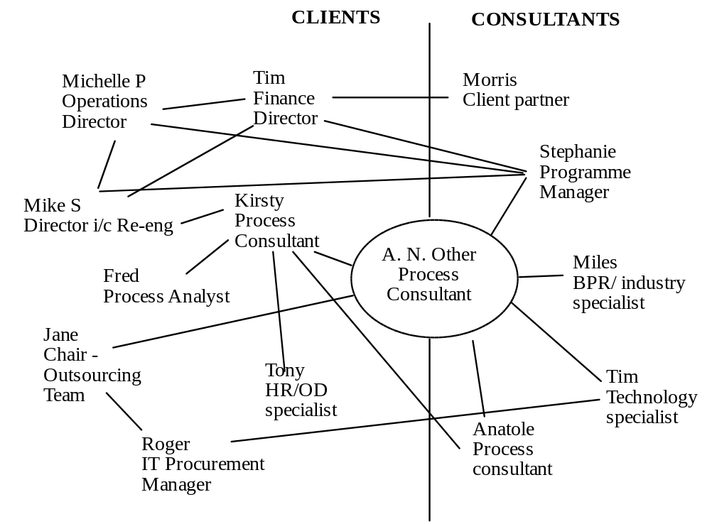

Identifying your sponsor
There is a Key Sponsor, a person ultimately in charge of all decisions and resources, for each of the three phases in a consultancy engagement: selling, undertaking and delivering.

Table 2
Sponsor/Stage | Selling | Undertaking | Delivering
Originator of work | K | I | I
Arranger of work | I | K | I
Implementer of work | I | I | K
Payer of work | I | I | I

K = Key Sponsor
I = Influencer

(For a fuller coverage of the stages and roles in the selling process refer to Neil Rackham, Making Major Sales)

During the SELLING process leading up to a decision to commence an engagement, it is likely that a number of client personnel will be contacted. The Key Sponsor in this phase is the person who makes the decision to engage consultants. This may not necessarily be the person most affected by your work, or indeed the person with whom you have the most contact during the engagement, or even the person to whose budget the fees will be charged - though all these individuals may influence the decision. See the case example in box 2 below.

Box 2: Case Study of a Selling Process: Food Manufacturer
A major UK-based food manufacturer had a number of subsidiaries. One of these subsidiaries had experienced problems with its costing system and stock valuations. Given that it had operated very tight margins (<5%) supplying national supermarket chains, cost control and early identification of adverse trends were crucial to profitability.

The holding company was well aware of the problem and had decided to seek consultancy assistance. It had additionally decided upon which firm to appoint. The subsidiary was unhappy both about the engagement itself and the firm to be appointed. It felt that the holding company was imposing its will.

Whilst unable to forestall the engagement, the subsidiary did manage to gain permission for a competitive quote to be obtained. The holding company whilst agreeing to this still anticipated that the work would be given to its preferred consultancy firm. A tendering process was agreed and issued to the two firms. It was to culminate in a presentation to a selection panel comprising representatives of both the holding company and the subsidiary.

The consultancy firm that had been asked for a competitive quote gained knowledge of the background during its process of gathering data and views prior to making the presentation. They knew that they had to satisfy a number of individuals that their requirements would be taken into account:
• the finance director of the holding company (commissioning the work)
• the finance director of the subsidiary (paying for the work)
• the chief management accountant of the subsidiary (agreeing to any recommendations resulting from the work)
• the factory manager of the subsidiary (having to implement any new system and being judged by the output of the same)

Great care was taken to listen to all these individuals during the tendering process. The result was a unanimous decision by the selection panel to choose the quote from the competitor firm. Not only did it correctly identify the relevant sponsors but also the original firm chosen by the holding company thought that the tendering process was a ritual and it had been predetermined to award the work to them.

Of course this was not the end of the story. During the undertaking of work and drawing up the recommendations the needs of the various sponsors had to continue to be addressed. Expectations had been aroused and had to be managed and met.

Having been commissioned to UNDERTAKE the work, the process of data collection and analysis can commence. This usually occurs both by requesting actual data to be provided and by interviewing client staff. The Key Sponsor in this ‘undertaking’ phase is the person who give permission for data to be released and agrees to the interview programme. This might not be the same person as the Key Sponsor during the selling phase.

This sponsor needs to be kept informed of progress, advised of any obstacles encountered, informed of any attempts to increase or decrease the scope of the work etc. In the event of the consultants being unable to resolve any issues with this sponsor, it may well be necessary to revert to the key ‘selling’ sponsor.

The Key Sponsor in the ‘DELIVERING’ phase is the person responsible for accepting your recommendations and implementing them. Again it will not necessarily be the same person as the key ‘selling’ and ‘undertaking’ sponsors. You need to maintain close contact with this sponsor during the course of the engagement so that recommendations contain no surprises. “Rolling the wicket before going in to bat” with your recommendations is usually vital to success in terms of gaining acceptance.

An a quick exercise, review a recent consultancy engagement known to you. Identify the Key Sponsor and Influencers in each of the 3 phases.

Understanding Politics
Having understood who the sponsor is, you also need to become aware of how the political system works. Politics can be defined as any activity concerned with the acquisition of power. Company/organisational politics are therefore concerned with the activities of an individual or group of individuals seeking to gain or retain power within an organisation.

The character of some organisations is open, encouraging candid discussion, allowing people to express personal interests and concerns, bringing covert issues into public view, people helping one another to succeed both individually and collectively. Other organisations, often those that claim to be more task-focused, discourage the expression of personal agendas and thereby push politics underground into a covert role.

In large corporates the sheer size and complexity of the client organisation means that the opportunities for its personnel to play politics are enormous. When the organisation is in a stable state, people may constantly be seeking to advance or to preserve their own positions or status. When an organisation is in a state of change, careers may be threatened and new opportunities exist to acquire power, so personal interests are in play. Consultants often brought in to assist an organisation with change, ignore this at their peril.

Any behaviour may or may not be an example of political activity. It all depends on the context. It is a reasonable rule to assume the person is innocent until you start to observe a repeating pattern. Here are some signs to look out for:
• statements being made about other individual’ views and the validity of these views
• selective data being used to prove a point
• minutes of meetings being tailored to suite an individuals viewpoint
• rejection of apparently logical grounds, of reasoned arguments
• personal agendas predominating over corporate agendas
• opinions being stated as factual evidence
• timing meetings so that people cannot be present
• lobbying activity
• pre-emptive actions prohibiting wider debate....

The case study in box 3 illustrates the political dimension to a consulting engagement.

Box 3: Case Study of Managing Politics in a Multinational Group
This group operated along lines adopted by many multinationals, namely, operating a matrix organisation structure comprising reporting along geographic, product and functional lines. Having said this, the operating companies in individual countries enjoyed high levels of delegated powers, even empowerment.

Matrix structures are both complex and provide fertile ground for political activity with the reporting lines crossing over each other. Additionally head office could be divided, rather simplistically into three groups:
• those returning from many years in operating companies to spend their remaining service coasting to retirement, with their career behind them
• those spending two or three years in head office, gaining experience of its activities prior to returning to an operating company with careers ahead of them
• those whose careers both behind and ahead of them were entirely spent in head office

The motives of individuals, and their resulting politics differed in each group.

The head office commissioned a consultancy engagement to recommend a management information system that could operate throughout the group. The concept was that each operating company could submit information on-line to head office. It would be capable of consolidation by geographic area and by product line. Functional reporting where required, would also be satisfied.

Whilst a system was designed, its implementation failed primarily for political reasons:
• individual operating companies resented having to supply information to head office fearing this would result in increased interference in their affairs
• geographic areas feared that product information could result in the product line organisation achieving dominance over the geographic organisation
• the system required compatibility of IT software throughout the group. There was fear that this would result in IT policy being increasingly centralised
• at least two of three groups of head office personnel being disinclined to do anything that would ‘rock the boat’ and at best making life uncomfortable, at worst damaging their future plans.

There are two questions arising from this case study:
• could the political problems have been avoided?
• should the engagement ever have been commissioned?

The key for the consultant is to recognise these activities are occurring and not to become unwittingly involved. Seek to model a non-political style, being up front about your concerns, needs and interests and providing a climate in which other people can also feel safe to express their true concerns. Transparency of your dealings with the client should result in political damage limitation to yourself.

Finally, it is important to identify whether you are engaging in a highly politically sensitive or politically active organisation. This is one area of risk to be aware of from the outset.

Risk management
If clients never had any problems, the consultancy industry would probably not exist. These problems, or issues, can manifest themselves in a variety of ways capable of a variety of solutions. But if the client is unable to find a solution, it follows that, by undertaking to find one, the consultant is taking a risk: the risk of failing to do so.

It also follows that the more difficult the problem, the greater the risk in undertaking to resolve it. It can also be argued that the greater the problem, the more a client may be willing to pay for its solution. If a consultancy practice wishes to undertake higher value added engagements, it is likely to expose itself to greater risk.

The complexity of larger organisations and the sheer size of their operations lead to the likelihood of issues being of a greater magnitude and the associated risk. Risk management is therefore a real necessity. It should not be seen as a reason for not undertaking a piece of work but rather as a means of enabling the work to be performed. The only way to completely avoid risk is not to undertake the work at all - but revenues will suffer!

The key to good risk management is an early assessment of where the risks may occur. Once identified, these risks may then be managed. It may be helpful to classify risk into five main categories:
• clients
• engagement
• methodologies
• people
• fees/contract

Some CLIENTS may possess attributes that will cause a consultancy to decline undertaking any work for them. Examples could include any organisation suspected of illegal activities eg money laundering, operating in a war zone, having the potential of conflict of interest with another client etc. In the majority of cases however, the risks will be capable of being managed.

Client areas of risk to examine can include:
• the credit-worthiness of the organisation
• the degree to which consultants have been used in the past and the client’s knowledge of how to use consultants to best effect
• the management level of the engagement sponsor and the vulnerability of this individual
• the complexity of the organisation and any potential political issues.

All ENGAGEMENTS carry a degree of risk or else consultancy assistance would not have been sought i.e. the client could undertake the work without help. The risks will not necessarily be in relationship to the fees being charged and could include:
• the urgency of the issue being examined; generally speaking the more urgent, the greater the risk. Recommending ways of improving profitability within, say, six months carries a higher risk than undertaking a feasibility study for a project that may take, say, five years to come to fruition
• working overseas is generally riskier than working in your home market given that you are likely to have better knowledge of the business and social environment of the latter; payment risk is also likely to be higher overseas
• if you have to accept a legal engagement contract that differs from your own standard contract, there is possibly a higher risk.

Regarding risks in the use of METHODOLOGIES, many consultancies have over the years developed proven methodologies for undertaking certain types of work. Examples include systems implementation, job evaluation, business process re-engineering, strategic analysis etc. Such methodologies have several advantages including:
• proven success
• high standard of documentation
• training of client staff
• reduction in time
• in-built quality assurance.

Assuming that the chosen methodology is appropriate, and it should not be force-fitted, its availability should significantly reduce risk. Conversely, the lack of a methodology may increase risk.

More than one senior consultancy executive has said: “you must look after your PEOPLE since they are your main asset - and they can walk away”. There are clearly risks inherent in any people business, like management consultancy. Allocating the appropriate consultants to an engagement is likely to be key to the success of that engagement. Attributes that need to be considered when allocating staff include:
• technical skill
• industry knowledge
• client knowledge
• personal chemistry
• teamworking
• engagement management skills
• communication skills...
and several others. If the required attributes for a particular engagement cannot be met then clearly there will be an associated risk.

Finally, let us look at risks associated with FEES AND CONTRACT. Not being paid for work undertaken clearly represents a high risk, arguably only exceeded by being sued for unsatisfactory work. The basis upon which fees are going to be paid has an impact on risk. ‘Time and materials’ is probably the least risky basis whereas a ‘contingency fee’, based upon results achieved, may be the most risky. Many contracts are based upon ‘staged payments’, often with the first payment due before work has started. This has the advantages of:
• ensuring that the client, and particularly the sponsor has the authority to pay
• covering mobilisation costs
• improving the consultancy firm’s cash flow.

Risks can also be increased where sub-contract consultants are employed or indeed you are a subcontractor yourself to another firm. Whatever the risks associated with fee payment, these are reduced by ensuring that the basis for the calculation and timing of payments are clear to all parties concerned.

In conclusion, all consultancy engagements have risks associated with them. A clear identification and analysis of these risks before an engagement is agreed should lead to risk management action and processes being put in place.

Programme management
In recent years, many large corporates have embarked on fundamental and sustained programmes of transformation. Typically such organisations require help from consultants in developing, initiating, leading and managing such programmes. This help can draw heavily on the resources of any consultancy firm and requires an in-depth understanding of how to manage complex programmes.

Gaining commitment to a major transformation by a large corporate is never easy - be it a flotilla or a supertanker. Indeed many Chief Executives when faced with a decision as to whether or not to set such a transformation in motion, ask two fundamental questions:

“In order for the process to start, I shall have to let go. How can I prevent corporate anarchy from breaking out and the organisation self-destructing?”
“How can I take people with me?”

The key to success is achieving alignment of purpose throughout the process. To do this there must be a clearly defined process. One of the simplest, but most powerful models has been supplied by Sharman and Tichy who describe 3 steps:
• Awakening
• Envisioning
• Re-architecting.
Blanchard and Waghorn similarly identify 3 steps: Envision, Propose and Deliver. This probably assumes that the awakening step has already occurred.

Without this alignment of purpose, a multitude of problems can arise such as:
• personal agendas predominating over corporate agendas
• lack of clear sponsorship
• unconnected and possibly conflicting projects being commissioned
• confusion and low morale amongst staff
• confused messages to the marketplace and loss of customers.

Take for example a hypothetical manufacturing company that by common consent is ‘bleeding to death’. Margins are down, staff turnover is high, market share is being lost, management is pressurised resulting in a disastrous bottom line. The Board is unanimous - ‘we have to change!’. Consultants are engaged and charged with drawing up recommendations and reporting back to the Board. The report is duly presented and at its heart is a recommendation that a massive cost-cutting exercise be embarked upon, primarily based upon headcount reduction. One can imagine the consequent dialogue amongst Board Members:

Finance Director: “marvellous, just what we need. This should increase margins and profitability”
Marketing and Sales Director:
“Fantastic, but only if it enables us to retain current margins, reduce selling process and increase market share”
Personnel Director:
“What’s that going to do to staff turnover - increase it still further. Who is going to manage the redundancy - me I suppose. Then there’s the costly effect on workforce morale”
Production Director:
“Not only that, but most of the people are in my area so I’ll be having to cut back. Fat chance of meeting any increased product demand”
Chief Executive: !!!!!!!?????

Perhaps it was the right recommendation but now not only is the company bleeding to death but there is also blood in the boardroom.

Imagine what it might feel like operating as a consultant in such an environment - indeed you might question if you should have taken on an engagement for a client in such a situation. Ask yourself how you might diagnose that this was the situation, how you m might rectify it or how you disentangle yourself if you had not realised the situation initially.

Assuming that there is a defined process in place, the consultant can contribute to each stage in a number of ways. Some of these are given below:

Awakening
• Collecting and presenting data to demonstrate that status quo is not an option and that a transformation is required
• Facilitating workshops where the data is presented and consensus on the causes and need for change are agreed

Visioning
• Undertaking studies of potential strategies for the future organisation
• Gaining commitment to the agreed vision
• Designing programmes to communicate the vision

Re-architecting
• Determining the projects required to build the new organisation that matches the vision
• Designing the overall implementation programme (resources, training, project interfaces etc)
• Assisting with the implementation (process and projects)

In order to manage the transformation programmes successfully it is necessary to understand:
• the organisation itself and what it is trying to achieve
• the component parts (projects) of the programme and how they interact
• the different roles of the individuals concerned with the projects

An organisation is not a structure but rather a system. One part of this system cannot be changed without an impact being made on the other parts of the system. Systems are difficult to explain in words alone since they are multidimensional whereas language is essentially linear. Figure 1 shows one way of describing an organisation. This was developed by Mike Jeans and others at KPMG

Figure 1
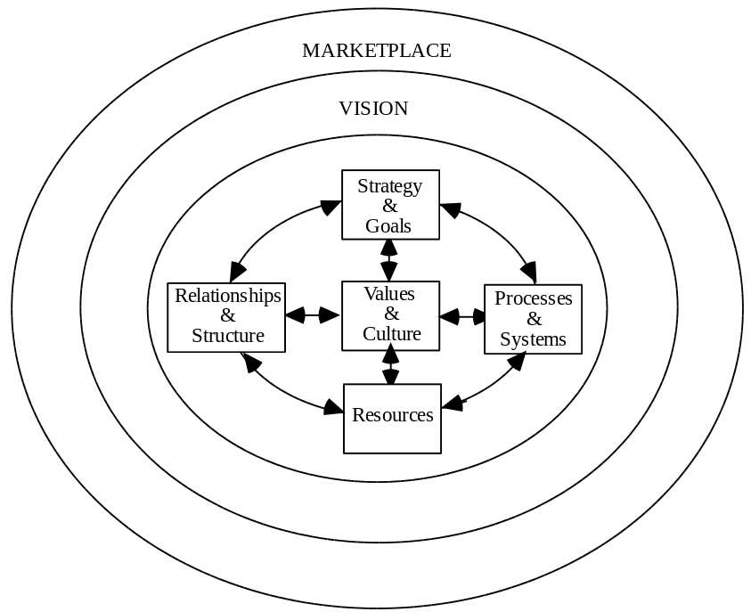

In any transformation programme, an organisation seeks to align its vision with the changed marketplace. The organisational system needs to be designed to achieve that vision. Each of the component parts may need to be altered but remain coherent with each other.

Another way of describing such a programme is shown at figure 2.

Figure 2
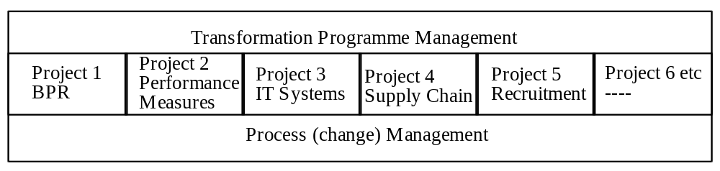

A Programme Manager is appointed to oversee the whole programme. This role requires skills and experience beyond that of a project manager. The success of the programme will demand an understanding of each of the elements depicted in figures 1 & 2.

The projects in Figure 2 are sometimes described as the ‘task’ elements. A Programme Manager appreciates the importance of each task, but also of the wider ‘process’, being aware of the connections and interdependencies of the tasks making up the whole programme. Thus Figure 2 shows the ‘process’ element underpinning the various projects which in total contribute to the overall transformation programme. Figure 3 gives an alternative depiction but adds the concept of the whole programme being one of dynamic interaction.

Figure 3
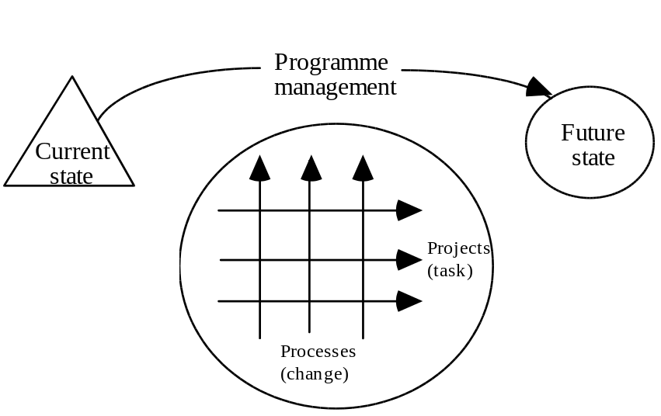

Whilst individual projects may relate to each other and have interdependencies, it can be seen that all change processes cut across all the projects. Such processes can include culture change, behavioural/attitude change, sponsorship programmes, communications etc. To manage such a programme in a large corporate represents an enormous challenge to a consultant requiring business knowledge, consulting skills and depth of experience of the highest order.

Using counterparts
Increasingly consultancy engagements are on a basis of working with the client rather than for the client - which sometimes manifests itself in doing something to the client. Phrases such as collaborative working, partnering, client ownership, knowledge transfer etc are becoming widespread.

The use of counterparts is another example of this trend though there can be other reasons and many of them particularly associated with large corporate clients. Counterparts are individuals from the client’s staff who work with the consultants as members of the engagement team usually on a full-time basis.

It is important to understand why the use of counterparts is being considered. The reasons include:
• reduced fees: by using client personnel to undertake some of the work, the external fees of an engagement may be reduced
• industry/client knowledge: client personnel can often bring key industry/client knowledge to the engagement being undertaken
• knowledge transfer: by working alongside consultants, client staff gain understanding of the approach/methodology being used and may be able to apply this to subsequent work thus reducing dependence on external consultants
• ownership: through being involved with the engagement client staff will share in the result and obtain a sense of ownership thereby reducing the need for the consultant to sell their conclusions
• personal development: exposure to consultants and their way of working can form a valuable part of the development of individuals. Depending upon the engagement, those individuals can also gain a broader understanding of the organisation for which they work.
Perhaps the most special and distinctive form of working with counterparts is a method that draws deeply on the separate knowledge and experience possessed by a client and a consultant, combining their thinking in a fast real time process that produces valuable, mould-breaking and unique solutions to the problem or issue under discussion. This is called a generative conversation (Ref: Diary of a Change Agent).

Depending upon the reason for using counterparts, the criteria for selection to fulfil the role will vary but could include individuals who:
• have been identified for career progression and who would gain from the experience
• are highly regarded within the organisation and whose involvement in the engagement will be viewed positively
• have the interpersonal skills to work in a consultancy role and as committed team members
• have a sound knowledge of the organisation and the industry in which it operates
Above all else individuals should not be chosen simply because they are ‘available’. The reasons for such availability would need to be closely questioned.

Creating conditions for engaging people
Given all that is now known about managing complex programmes in large corporates, would it be true to say that bringing people on board has become a predictable and reliable process? No. Far from it. The Process (change) Management component in Figure 3 above is not easily reducible to a set of well-ordered steps. In fact it is more an art than a science.

We might all prefer our success to be applauded when we have ticked off everything on our list of predefined tasks. Unfortunately, as consultants we are usually judged on outcomes. One of the most important measures of our success is whether we created the right conditions for people affected by the programme to come on board, and put their energy behind making it succeed. There is lots to learn from consultants who did not attend sufficiently to this.

Staff in most large corporates, now delayered and downsized, are still having severe difficulties adjusting to new demands. Cary Cooper (ref) identified that two thirds of all managers in the UK have undergone a major organisational change in the last 12 months and there is a growing gap in the perceptions of this between two groups: directors and above, senior managers and below. The first group judges the company’s position to be better following the changes, whereas the second group judge the position to be worse.

Cooper’s research also indicates the increase in reported profits following organisational change is accompanied by a reduction in loyalty, morale, motivation and security, plus an increase in working beyond the contracted hours, and a growing concern about the impact of work upon home life. This represents a form of damage to the goodwill in the employee relationship which carries with it a future cost. Even amongst CEOs, an astonishing 25% reported a desire to leave their current job because of its impact on family life, and a wish to engage in some other less-disruptive form of work such as consultancy!

Eric Miller (ref) highlights the psychological withdrawal in the workplace since the performance culture of the 1980s and 90s. To counter this companies have launched countless mission and values programmes attempting to win hearts and minds, but. beneath superficial shows of commitment, we have produced deeper feelings of anxiety, cynicism, resistance, detachment, depression and alienation.

Is it OK to produce psychological withdrawal, or do we need people to be present, and engaging themselves fully in their work? Plainly in unpredictable, challenging times, when increasingly we are engaged in service-based knowledge work, we do want people to be present, alive, engaged in their task.

What do you need to know about the conditions that produce presence and human engagement?

Learning the art of engagement involves educating your senses, becoming perceptive, making fine discriminations. Everyone has different needs in a change programme. Do not judge others by your own needs. Understand your own needs by talking with other consultants and reflecting privately using a diary method (Diary of a Change Agent ref). Many consultants enjoy the thrill of the new and are bored easily by stability. Your clients may be oriented differently. If they are, you stand little chance of persuading them to enjoy uncertainty. You have to begin from where they are.

Effective consultants, skilful in the art of engaging people, observe how people are behaving as the wider programme advances, find out and acknowledge their feelings, encourage them to face realities, support them in discovering options and making choices.

Do not make the mistake of ignoring or diminishing the achievements of the past. Bill Bridges’ work on transitions reminds us that you have to give people time after an outside change eg. a new organisation structure or an office move, to make an inner change, a mental readjustment. It helps if you honour successes from the past, perhaps having a celebratory party to mark and ending. It also helps if you let people bring something of the past with them: a photograph, a procedure, a momento. Primitive rites of passage performed this function, allowing lives to move on. If you don’t let people manage their endings they do not move on, their minds remain stuck in the past.

Recognise that you have an important role in coaching the leaders, helping them to find the right balance between providing certainty and a clear direction, and leaving problems for others to solve, thereby treating people as adults, demonstrating trust and giving them a reason to get involved.

Remain in close contact with as many as possible of the people and groups affected by a programme. Then you will be in touch with their concerns and be able to reflect these in programme priorities. For example, you will know whether you need to put more resource into communicating, training, reward, or thanks and recognition.

Whilst most programmes are deficient in many ways, there are four fundamental conditions that any person needs if they are to come on board with a change programme:
• A sense of dissatisfaction with the status quo
• A sense of the future state being attractive, desirable
• Knowing what the first steps are and judging these to be feasible
• Perception that the benefits exceed all the costs.

The more experience you gain as a consultant, the more you will become practiced in helping people express their own feelings and values in relation to a change that is affecting them. Although this might appear to be distracting them from the task, or to be wallowing in the past, you may come to realise that these conversations with the client, properly conducted help them to let go of an old order, bring about ownership of the task and speed up its accomplishment.

Such conversations can happen one to one and in small groups, but increasingly large numbers of people are assembled in special workshop style meetings to create together the changes that their organisation needs to make and achieve fast, simultaneous alignment. There are a number of proven large-scale intervention processes that you can learn to use. Such meetings need not be confined to a single stakeholder such as employee, and can be more powerful if they involve representatives from several of the vital relationships (customer, supplier, investor, employee and community).(Ref)

Shaping the future
Large corporates are an increasingly important force in the world. An effective strategic engagement with a large corporate, whilst probably complex and long-lasting, plays an important part in shaping the future of that organisation and its dealings with its employees, customers, investors, suppliers and wider community. This important work can be deeply satisfying and rewarding.

We have underlined the importance of dealing with the large corporate as a whole system in which the parts interact, in which changes in one part cause effects in other parts. Some consultants address their task quite narrowly, from a single professional viewpoint, be it finance, sales, IT or HR. We hope that regardless of your own professional background, what we have described will help you take an integrated view of the consulting role, and better manage the risks involved. More than this, we hope that by reading this you have found some extra ways to rise to the larger opportunity, to create more effective conditions for engaging people, to generate greater value, and make a positive difference.

Our closing quote from a satisfied client underlines the challenge you face:

“You need to understand that we are a graveyard for consultants! But your consultants were able to operate at 30,000 feet and at ground level - and to know when required to operate at each level”.

Good luck!

References

1 Bauman, B, Jackson, P & Lawrence J, 1997, From Promises to Performance, A Journey of Transformation at SmithKline Beecham, Harvard Business School Press.

2 RSA Inquiry 1995 Tomorrow’s Company: The Role of Business in a Changing World, Gower.

3 Morgan G, 1986, Images of Organisations, Sage Publications, London.

4 Rackham N, 1987, Making Major Sales, Gower, Aldershot

5 Tichy N and Sharman, 1993, Control Your Own Destiny or Someone Else Will.

6 Blanchard K and Waghorn T, 1997, Mission Possible, McGraw-Hill, New York.

7 Page T, 1996, Diary of a Change Agent, Gower, Aldershot

8 Cooper C, 1997, The Psychological Implications of Changing Patterns of
Work, RSA lecture, 19 November 1997.

9 Miller E, 1997, From Dependency to Autonomy, Maresfield Curnow Brainstrust.

10 Bridges B, 1996, Transitions, Nicholas Brealy

11 Bunker B B and Alban B T, 1997, Large Group Interventions - Engaging the Whole System for Rapid Change, Jossey-Bass.

_______________________________________________________

Choose PRINT or SAVE AS.. under your browser's FILE menu if you wish to read this article later.

Please hit the BACK button on your browser to return to website.

